Project Write-Up: Which factors make us happy?

By Kirsten Taufer

The World Happiness Report is commissioned by the United Nations every year, beginning in 2012. Every year, Gallup polls another 500-1,000 people in each of 156 countries, asking questions like:

*“*Please imagine a ladder with steps numbered from zero at the bottom to 10 at the top. The top of the ladder represents the best possible life for you and the bottom of the ladder represents the worst possible life for you. On which step of the ladder would you say you personally feel you stand at this time?”

(Source: <https://news.gallup.com/poll/122453/understanding-gallup-uses-cantril-scale.aspx>)

Based on the responses, Gallup calculates an average Happiness Score for each country. Some other factors that are included in the report are GDP per person, perceived familial connection, perceived social support, healthy life expectancy, and perceived freedom to make life choices. Within the report, the three factors that most highly correlated to happiness score were GDP per capita (r=0.81), familial connection (r=0.75), and healthy life expectancy (r=0.78). See the below correlation table:

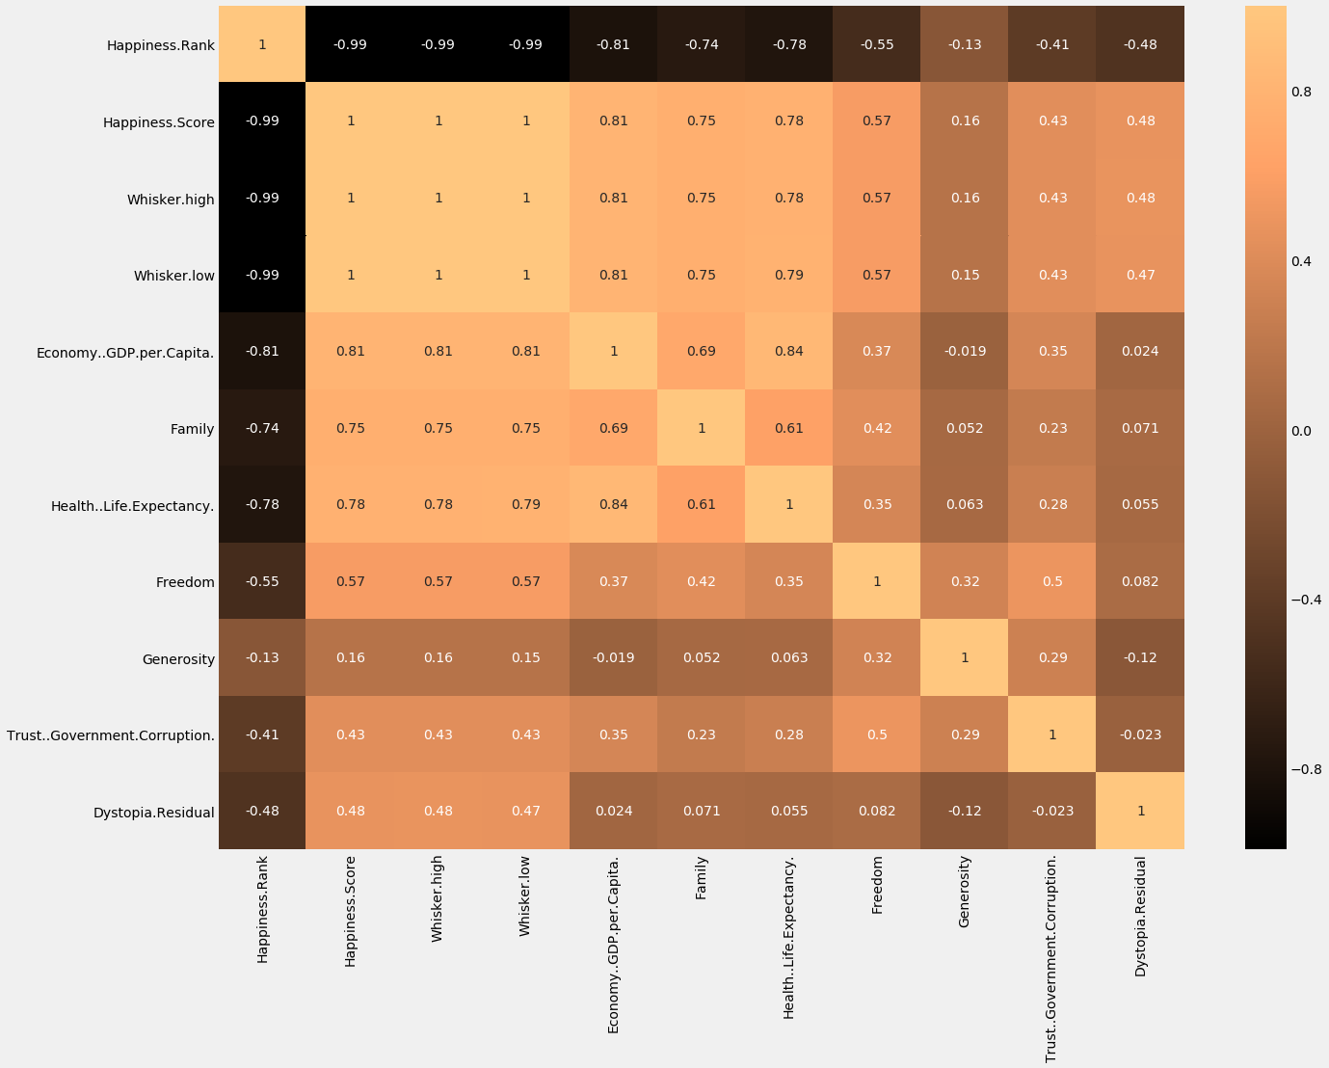

We were interested in some other factors that might influence happiness, particularly facets of American life that seem to influence our happiness here: mental health, use of technology, crime, education, population density, and more. The map below shows happiness scores for 2019.

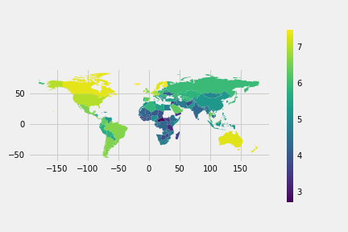

**Mental Health Factors**

In the United States, we have seen a steady increase in mental health disorder prevalence over the past 10 years. Although the United States ranks in the top 25 happiest nations, its rank and average score has seen a decline since the beginning of the report. Could there be a connection? We hypothesized that happiness score worldwide should decline as prevalence of mental health disorders increases. Please see the linear regression below:

The true correlation was the directional opposite of our prediction! Our analysis compared the Happiness Score for each country and the combined prevalence of many measures of mental health, including schizophrenia, bipolar disorders, eating disorders, substance use disorders, depression and anxiety disorders, and alcohol use disorder. What could possibly explain the difference between our hypothesis and this analysis? Restrained by time, we were not able to find data to help us reason through this seeming paradox, but we could guess some underlying causes. First, in many cultures across the world, mental illness diagnosis and treatment are stigmatized, which discourages many from coming forward and being counted. Also, mental health treatment resources vary greatly based on geographic area. One could imagine that there are more mental health resources in more developed countries, so more people can be diagnosed. Maybe this paradox reflects faults in data gathering. Another possibility is that, in more developed countries, where the happiness score is typically higher, people have more leisure time, and that allows inhabitants more time to ponder existential questions, worry, ruminate, creating the circumstances for more mood, eating, and substance use problems.

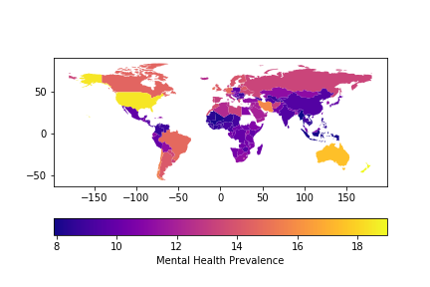

Another mental health measure we decided to examine was the frequency of suicide. We hypothesized that there would be a negative correlation between happiness and suicide rates. Certainly, if there are happier people in a place, there would be fewer people committing suicide. Results are below:

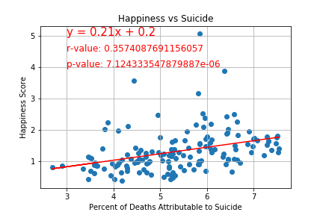

Again, we observed the opposite of our prediction. Instead of a negative correlation, there was a moderate but significant positive correlation between happiness and suicide rates. Why? Again, causation is beyond the scope of this project, but we can guess. It’s possible that, when a sad person lives in a place where they’re surrounded by happiness, their lives feel worse by comparison. Presumably, the converse is true, if you’re surrounded by unhappy people, your life might seem better in comparison. It may also be that, in areas with low life expectancy and low happiness, life is so short there is no point in killing oneself, since war, disease and famine might kill one sooner. We feel these results reflect the unpredictable nature of suicide, rather than further insight into happiness. See the map below to compare worldwide suicide rates.

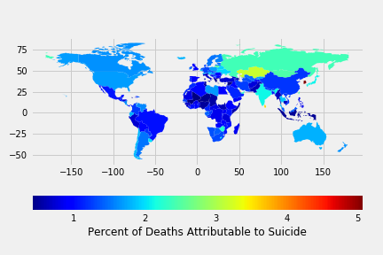

Health care access, in general, seems to have an impact on happiness. In one analysis, we examined physicians per 1000 people.

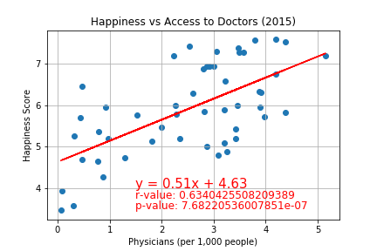

The data we obtained only included 50 countries, yet there was still a significant positive correlation between physician availability and happiness scores, suggesting that happier countries have greater access to healthcare overall.

One last measure of mental health that was available for examination was alcohol use. In my experience, alcohol use can drive down quality of life and induce depression and anxiety, depending on the severity and frequency of its use. Based on this, I predicted that alcohol consumption and happiness would be inversely related. Please see the results below:

Again, my prediction was wrong. Although this is not a strong correlation, it is statistically significant, and it relates a direct relationship between happiness and alcohol consumption. I stand corrected – apparently, I need a drink.

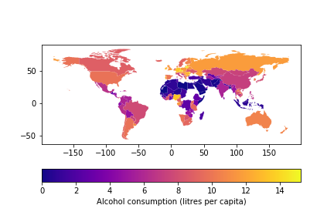

**Weight and BMI**

This is another area where assumptions based on trends in the United States cannot necessarily be extrapolated to the rest of the world. The United States is experiencing what has been termed an “obesity epidemic.” The percent of the population that can be classified as obese (BMI => 30) is rising, and obese people represent a third of our population. We predicted that obesity would negatively impact happiness scores, since it seems like obesity has so many negative affects on the quality of the lives of those who are obese. See below for the analysis:

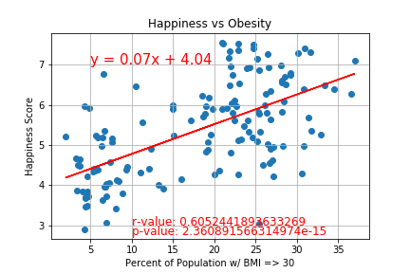

Rather than having a negative affect on happiness, our data showed that the countries that have a greater percentage of obese people in their population were happier.

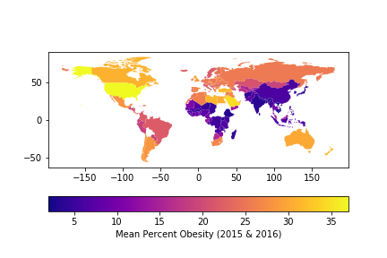

We did another analysis of happiness score compared to the percent of the population considered to be overweight (BMI =>25 and <30). Results are below.

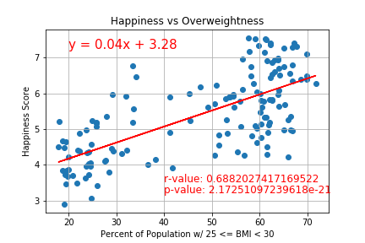

Which supported the findings regarding obesity. The more overweight the population, the happier they are. There is some truth in the “fat and happy” stereotype, apparently. Just to be sure, we looked at the data for percent of underweight people (BMI < 18).

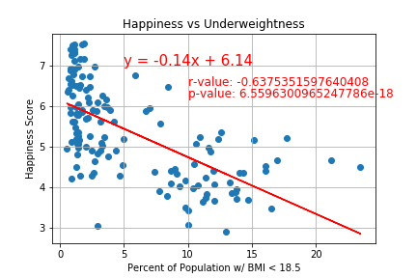

There’s a significant negative correlation between happiness and the percent of the population considered to be underweight. This might not be a surprise to many: an abundance of food at the very least is anxiolytic, allowing people to enjoy their lives more, where food scarcity is an obvious stressor. Another measure of food availability we examined was the price of food compared to income, or percent of consumer spending on food.

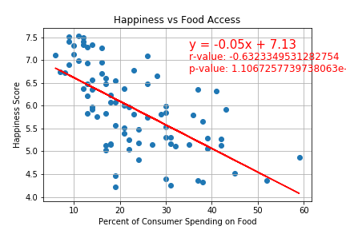

Unfortunately, the data we were able to find on food spending only included 86 countries, but the data we had shows a clear, negative correltation between happiness and the percent of consumer spending that was used on basic survival. In general, we can say that one is better off being fat and happy rather than thin and struggling to feed oneself! Take that, modern medicine!

As a last measure of well-being, I was curious about the effect of environmental factors on happiness. In Colorado, when we have had summers filled with forest fires and the resultant smoke, I noticed many were adversely affected by the smoke in the air, both in their ability to breathe and their mental state. We compared air pollution concentration to happiness.

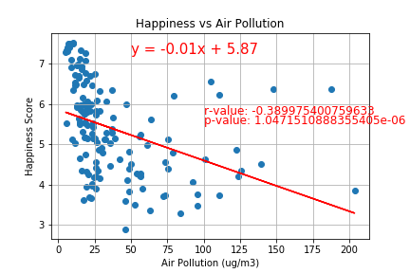

Although this is a moderate correlation, it suggests that, as air pollution rises, happiness declines.

Although the scope of this investigation did not include examination of other environmental factors, our findings imply that the environmental impact on happiness might be multi-faceted and additive. In further analysis, it would be interesting to look at the effect of clean vs polluted waterways, and protection of natural habitat for local wildlife.